# CS 340 README

## Project Two: Animal Shelter

An application that searches for rescue animals in a database and extracts informational data on suitable rescue animals.

Using the Austin Animal Center (AAC), the user would be able to search and filter the database. It is beneficial in demonstrating my skills in data manipulation, databases, user interaction, charts, filter, geolocation mapping and website design.

## Motivation

*The company, Grazioso Salvare, is an innovative international rescue-animal training company that needs an application to look for certain profiles to train to help rescue humans or other animals in life-threatening situations. They need to identify and categorize available dogs that meet the criteria to train. With this, they can categorize a specific group of dogs, for example, search-and-rescue training where dogs no more than two years old are more effective.*

## Getting Started

1. *Using the terminal, log in and access Mongo, importing the aac_shelter_outcome.csv file into the existing AAC database, animals collection.*
2. *Authenticate a user to have access to the database. The user must have an Admin and aacuser to properly log onto the database.*
3. *Whilst having python installed (refer to Installation for further necessities), run the problem on Jyuputer Notebook.*
4. *Once running the program, click the Dash App link to open the dashboard.*

## Installation

*Up to date versions of Jupyter Notebook and Python. Access to libraries: PyMongo, Dash, Plotly, Pandas and Leaflet. These will be used to run .py and .ipynb files and to be displayed via Dash.*

## Usage

*Use this space to show useful examples of how your project works and how it can be used. Be sure to include examples of your code, tests, and screenshots.*

### Code Example

*Running Dash and accessing the Grazioso Salvare dashboard: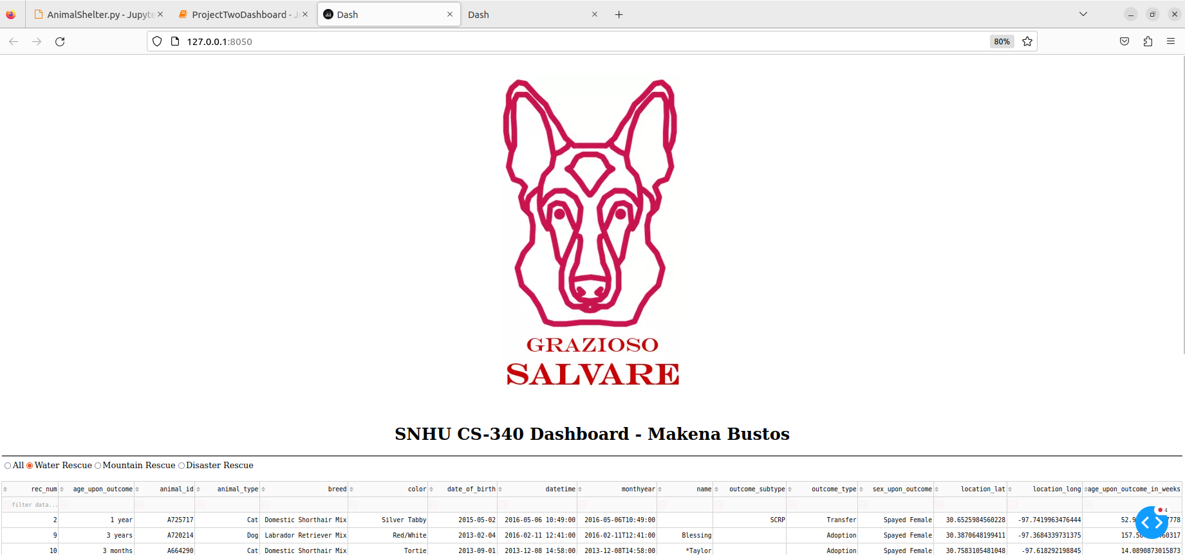Showing the pie and map UI: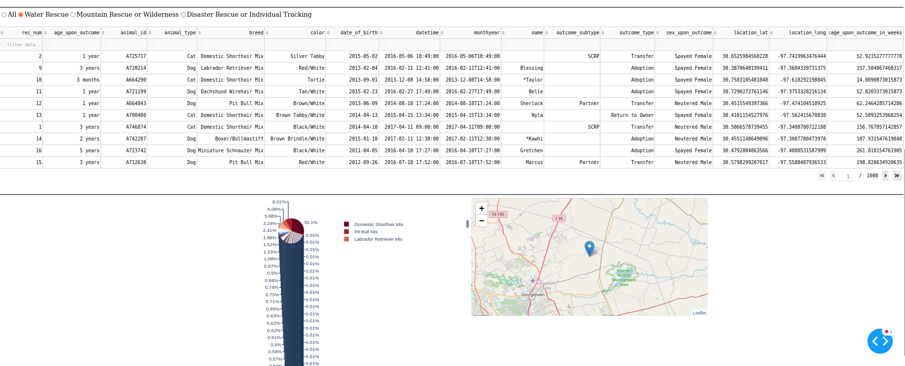*

### Tests

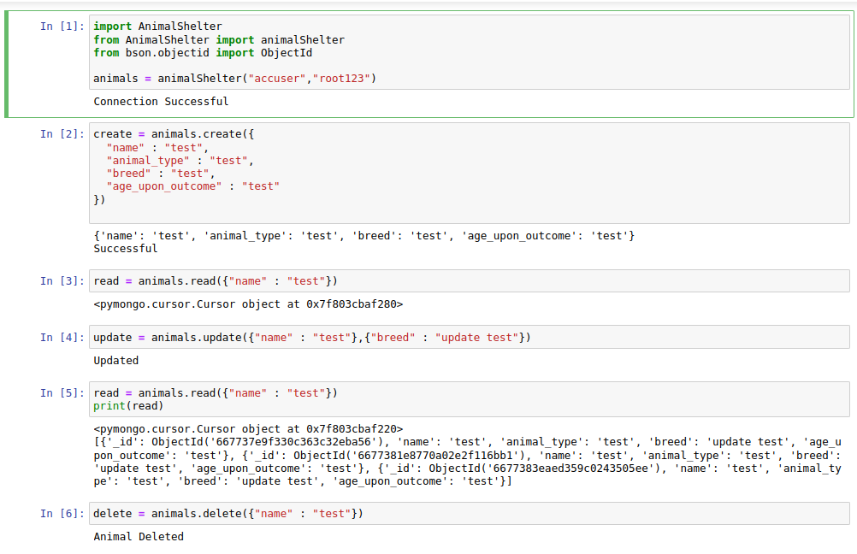

### Screenshots



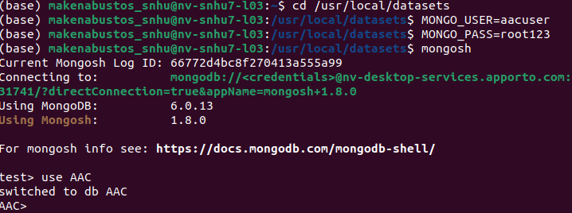

**Errors:**

Ran into an error where the radio filter is unable to display filter of different types of suitable rescues to be updated on the database table. Also ran into an error in regards to the design of the pie chart. Wanted the desired outlook to take the three top popular breeds and to enlarge it to a readable format.

## Contact

Your name: Makena Bustos